# Simulations of Selected Topology

As explained in the previous section, the three phase diode rectifier and buck converter topology is selected due to its advantages. Then, the simulations of this topology are presented in this section. First, the three phase diode rectifier is simulated, after that the voltage-current waveforms of buck converter are analysed. Last, the total topology is simulated for ideal case, and the streess values are determined for rectifier diodes, MOSFET or IGBT and free-wheeling diode.

## The Three Phase Diode Rectifier

The circuit schematic of three phase diode rectifier is given in Figure#.

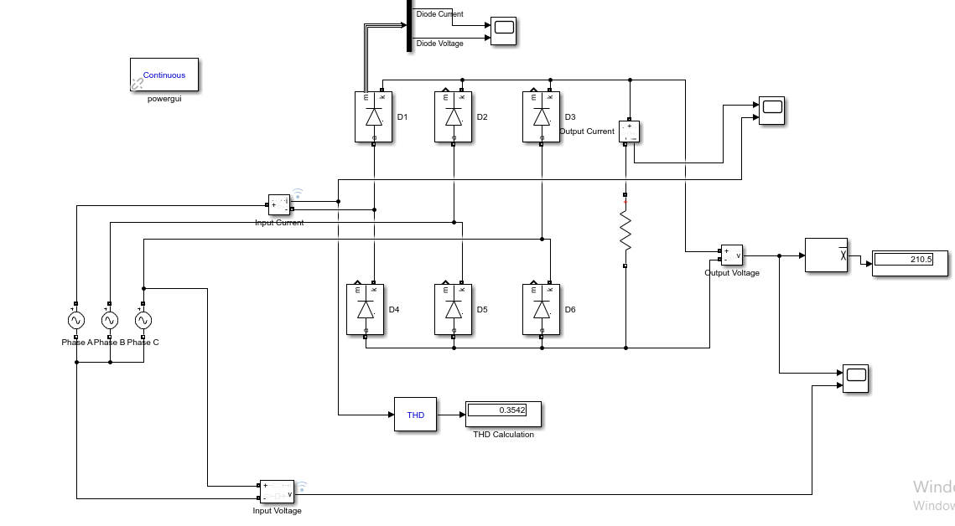

Figure : Circuit Schematic of Three Phase Diode Rectifier

As a requirements of the project, the output voltage of all system must be less than 180 $V_{dc}$. Then, we decided to limit the output voltage as 170 $V_{dc}$. Also, the duty cycle of the buck converter must be between $0<D<1$, then we decided to limit the duty cycle as 0.8, the higher the duty cycle values may not be possible in non-ideal world. According to following calculations, the required input voltage is found :

$$V_{out}=\frac{3\sqrt{6}}{π}×D×V_{ph}$$

$$170 V=\frac{3\sqrt{6}}{π}×0.8×V_{ph}$$

$$V_{ph}=90.8473 Volts$$

According to calculations, the input voltage can be between 90 – 100 Volts for at most 180 $V_{dc}$. The precise value of input voltage will determined when the tests are done. Now, we applied 90 Volts to the input for simulations.

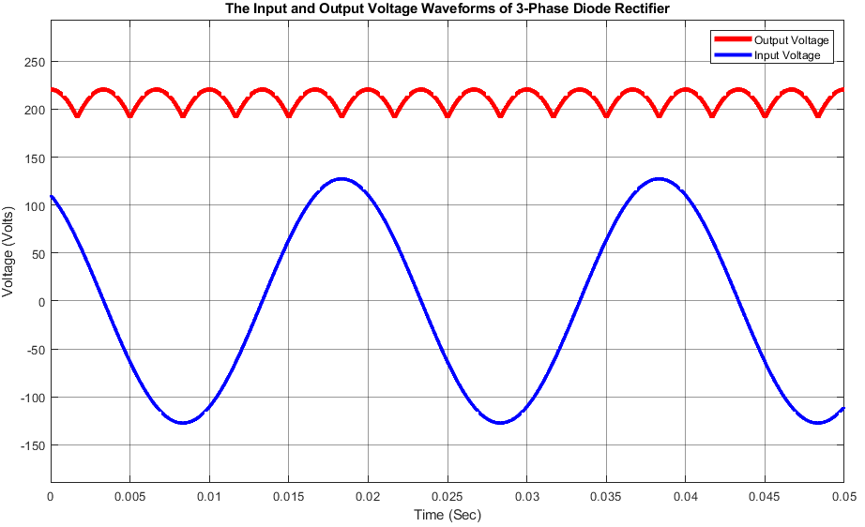 The output and input voltage waveform of three phase diode rectifier for 90 Volts phase voltage is given in Figure 2.

Figure : The Input and Output Voltage Waveforms of 3-Phase Diode Rectifier

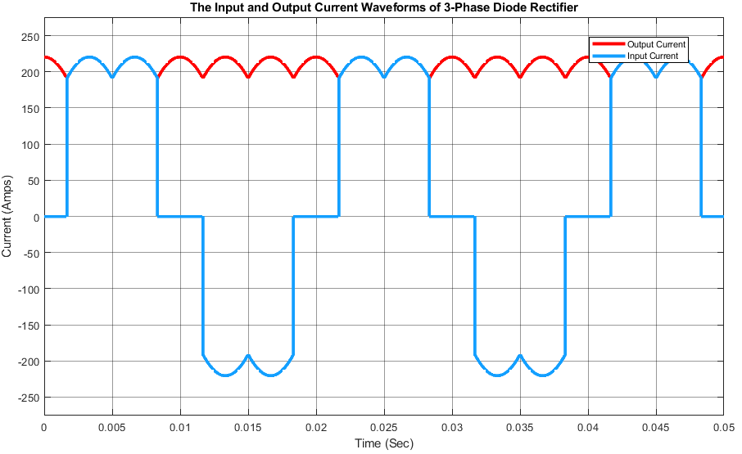The output and input current waveform of three phase diode rectifier for 90 Volts phase voltage is given in Figure 3.

Figure : The Input and Output Current Waveforms of 3-Phase Diode Rectifier

The waveforms in Figures 2 and 3, are as expected for ideal case which is no line inductance and diodes are ideal. Also, the load of the rectifier is a resistor without capacitance, so the ripple voltage is higher than capacitance case.

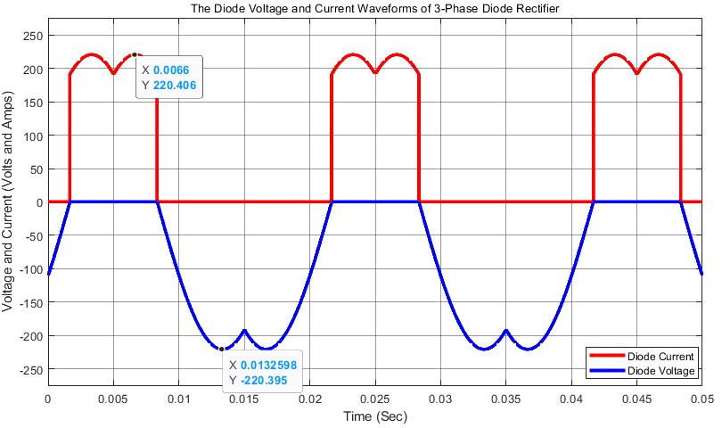The diode current and voltage of rectifier is given in Figure 4.

Figure : Voltage and Current of Diode in 3-Phase Diode Rectifier

Figure 4 shows the streesses of the diodes. As can be seen the maximum blocking voltage of the diode is 220 Volts and the maximum current that diode can carry is 220 Amps. However, this values are only valid for the resistor load case. In total topology, we have buck converter and DC motor,so the componet selection is made by using later simulations.

## Buck Converter

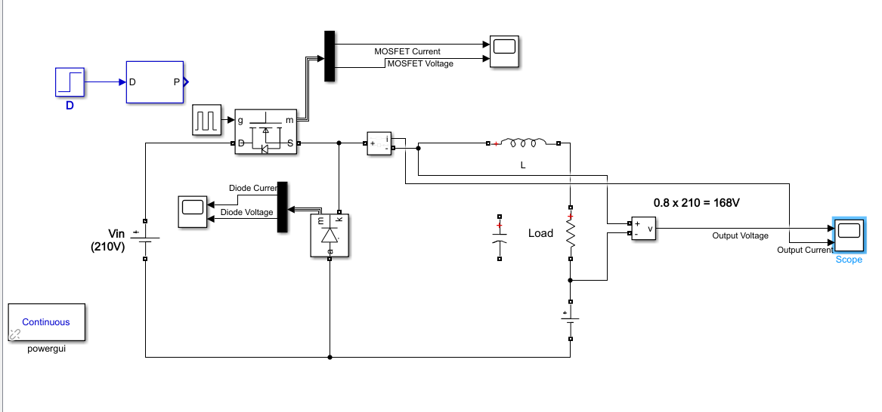The circuit schematic of the buck converter is given in Figure 5. For the switch, the MOSFET is used in the simulation, but IGBT is also can be chosen.

Figure : Circuit Schematic of Buck Converter

Figure : The Circuit Schematic of Buck Converter

When we decided to the duty cycle, we also considered the DC motor. Since, the DC machine is standing at the beginning, applying high duty cycle at the initial may damage to the machine. Hence, we decided to increase the duty cycle slowly by using potentiometer in the controller. The controller is used for the determine the gate signal of MOSFET or IGBT. Therefore, at the start-up, the duty cycle is arranged as 0.1 and increase gradually until 0.8. In this buck converter simulation, the duty cycle is 0.1 in order to see stresses of the components at start-up. Initially, there is no back emf in the motor, the we gave the 0.1 Volts to the load side of buck converter. Also, we did not add a LC filter, since the DC motor itself is already a huge RL load. Then we don’t need to another filter in this simulations. The load variables are given as in the motor parameters. Also, we decided to apply 10 kHz as a swithing frequency to the MOSFET or IGBT. The following figures shows to voltage and current waveforms of output, MOSFET and free-wheeling diodes at the start-up, which is the duty cycle is given as 0.1.

The voltage and current waveforms of the output is given in Figure 6.

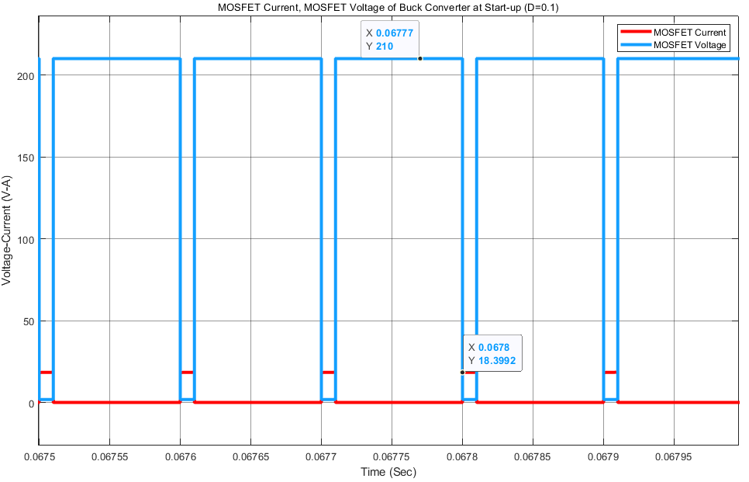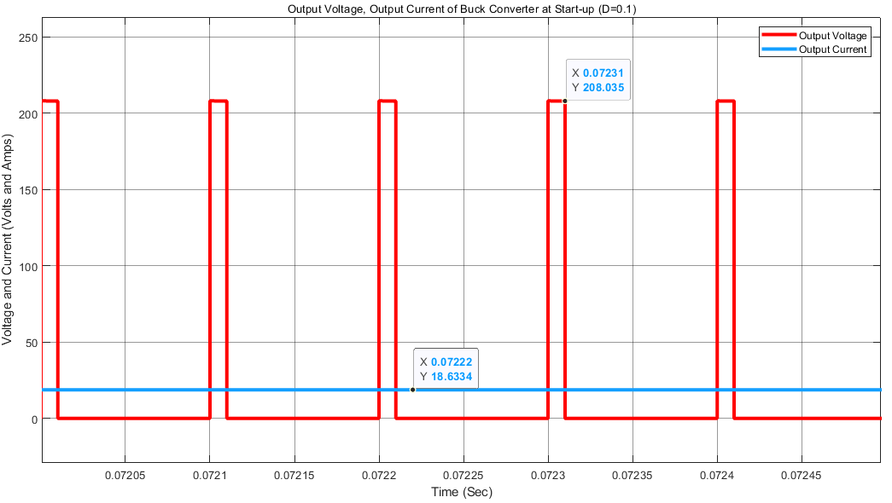The voltage and current waveforms of MOSFET at the start-up can be seen from Figure 7.

Figure :The Voltage and Current Waveforms of MOSFET in Buck Converter

Figure 6: The Output Voltage and Current Waveforms of Buck Converter

As shown in Figure 7, the maximum blocking voltage of MOOSFET is about 210 Volts and the maximum value of current is 18 Amps for start-up.

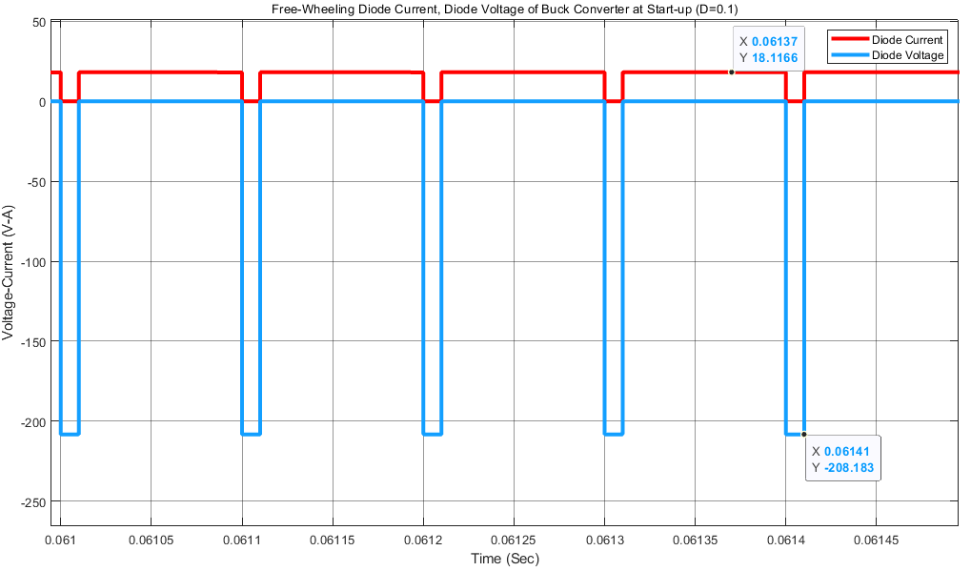The voltage and current waveforms of free-wheeling diode in buck converter at the start-up can be seen from Figure 8.

As can be seen from Figure 8, the blocking voltage at the free-wheeling diode is about 210 Volts. And, the maximum forward current value is 18 Amps.

## Three Phase Diode Rectifier and Buck Converter